Reanalysis of the IBTS and BTS datasets Datras -June 2021

Ruth Kelly

In order to provide a comparison product to the DATRAS swept area flexfile products co-developed by DATRAS and the IBTS and WGBEAM working groups (https://datras.ices.dk/Data_products/Download/Download_Data_public.aspx), WK_SAE decided to rerun and the Groundfish Survey Monitoring and Assessment Data Products using the methods specified in Moriarty et al 2017 and the current DATRAS datasets. This provides an alternative methodology with which to compare the flexfile outputs, and has the added benefit of providing a longer time-series than the current DATRAS flexfile swept area for many regions. Conversely, the DATRAS flexfile data product is based on survey specific equations provided by survey coordinators, and could therefore potentially provide more accurate estimates of missing data for the time period covered by these data products.

This data update to the Groundfish Survey Monitoring and Assessment Data Products includes only the ‘Sampling Information’ product, based on the haul information (HH) files in DATRAS, and not the ‘Biological Information’product which was beyond the remit and scope of the WK_SAE workshop. DATRAS datasets were downloaded on the on either the 8th/9th of June 2021 and reference copies of the downloaded data, code and data product are provided for the reproducibility at: . Note that this data product includes all valid hauls which met with the quality assurance criteria applied by Moriarty et al. 2017, however, the Standard Survey Area protocols which exclude hauls from locations that do not have consistent temporal sampling have not been applied (i.e. this data product include the full spatial extent of the survey data). It is expected that data users will make their own decisions about which hauls to include in future workshops (e.g. WK_ABSENS) and other analyses.

This update is based on original code provided by Moriarty et al at : <https://github.com/MarineScotlandScience/MSFD-QA-GFSM-A-DP/releases> as the updated code files from the reanalysis are provided on the ices-dev-tools github page : <https://github.com/ices-tools-dev/MSFD-QA-GFSM-A-DP>. It is intended that this repository should be a working location for future development of this product by ICES working groups and collaborators going forwards.

**Table** – DATRAS datasets included in the rerun product. Values show the number of hauls per year included in the final Sampling Information product. DATRAS survey names refer to the current dataset names as downloaded from the DATRAS data centre, GFSM survey names are given below for continuity with previous data product versions.

|  |  |  |  |  |  |  |  |  |  |  |  |
| --- | --- | --- | --- | --- | --- | --- | --- | --- | --- | --- | --- |
| **DATRAS**  **survey name** | **BTS** | **EVHOE** | **FR-CGFS** | **IE-IGFS** | **NIGFS** | **NS-IBTS** | **PT-IBTS** | **ROCKALL** | **SCOROC** | **SCOWCGFS** | **SWC-IBTS** |
| **GFSM**  **Survey name** | GNSNetBT3/  GNSGerBT3/  GNSEngBT3* | CSBBFraOT4 | GNSFraOT4 | CSIreOT4 | CSNIrOT1/  CSNIrOT4 | GNSIntOT1/  GNSIntOT3 | BBICPorOT4 | WAScoOT3 | WAScoOT3 | CSScoOT1/  CSScoOT4 | CSScoOT1/  CSScoOT4 |
| 1983 | - | - | - | - | - | 380 | - | - | - | - | - |
| 1984 | - | - | - | - | - | 459 | - | - | - | - | - |
| 1985 | - | - | - | - | - | 515 | - | - | - | - | 59 |
| 1986 | - | - | - | - | - | 526 | - | - | - | - | 38 |
| 1987 | 64 | - | - | - | - | 540 | - | - | - | - | 50 |
| 1988 | 70 | - | 66 | - | - | 404 | - | - | - | - | 50 |
| 1989 | 82 | - | 61 | - | - | 426 | - | - | - | - | 46 |
| 1990 | 181 | - | 75 | - | - | 379 | - | - | - | - | 90 |
| 1991 | 198 | - | 81 | - | - | 424 | - | - | - | - | 105 |
| 1992 | 179 | - | 60 | - | 79 | 344 | - | - | - | - | 75 |
| 1993 | 178 | - | 65 | - | 89 | 374 | - | - | - | - | 85 |
| 1994 | 173 | - | 88 | - | 82 | 363 | - | - | - | - | 77 |
| 1995 | 194 | - | 89 | - | 77 | 338 | - | - | - | - | 101 |
| 1996 | 234 | - | 61 | - | 82 | 329 | - | - | - | - | 106 |
| 1997 | 218 | 129 | 90 | - | 85 | 363 | - | - | - | - | 122 |
| 1998 | 218 | 125 | 83 | - | 89 | 677 | - | - | - | - | 111 |
| 1999 | 245 | 119 | 102 | - | 87 | 721 | - | 41 | - | - | 121 |
| 2000 | 250 | 120 | 101 | - | 85 | 701 | - | - | - | - | 137 |
| 2001 | 252 | 151 | 108 | - | 100 | 771 | - | 44 | - | - | 134 |
| 2002 | 311 | 152 | 98 | - | 113 | 759 | 66 | 29 | - | - | 141 |
| 2003 | 305 | 148 | 96 | 150 | 119 | 746 | - | 60 | - | - | 153 |
| 2004 | 389 | 138 | 92 | 159 | 102 | 721 | - | - | - | - | 145 |
| 2005 | 336 | 143 | 108 | 140 | 94 | 726 | 89 | 38 | - | - | 149 |
| 2006 | 299 | 127 | 106 | 168 | 90 | 709 | 88 | 32 | - | - | 132 |
| 2007 | 360 | 145 | 96 | 171 | 102 | 697 | 96 | 42 | - | - | 147 |
| 2008 | 333 | 147 | 101 | 166 | 53 | 719 | 87 | 37 | - | - | 123 |
| 2009 | 361 | 135 | 100 | 164 | 120 | 682 | 93 | 41 | - | - | 127 |
| 2010 | 320 | 139 | 87 | 176 | 120 | 694 | 87 | - | - | - | 58 |
| 2011 | 323 | 151 | 103 | 159 | 117 | 723 | 86 | - | 45 | 112 | - |
| 2012 | 346 | 129 | 94 | 172 | 118 | 708 | - | - | 36 | 130 | - |
| 2013 | 351 | 140 | 93 | 176 | 112 | 711 | 93 | - | 31 | 92 | - |
| 2014 | 289 | 155 | 94 | 170 | 112 | 665 | 81 | - | 47 | 121 | - |
| 2015 | 297 | 148 | 73 | 147 | 120 | 726 | 90 | - | 42 | 120 | - |
| 2016 | 300 | 157 | 73 | 172 | 124 | 741 | 85 | - | 48 | 123 | - |
| 2017 | 330 | 25 | 66 | 149 | 118 | 714 | 88 | - | 41 | 117 | - |
| 2018 | 354 | 155 | 73 | 153 | 120 | 713 | 49 | - | 41 | 116 | - |
| 2019 | 341 | 148 | 65 | 161 | 121 | 696 | - | - | 44 | 124 | - |
| 2020 | 342 | 155 | 59 | 127 | 115 | 695 | - | - | 40 | 113 | - |
| 2021 | - | - | - | - | - | 374 | - | - | - | 63 | - |

* The Belgian BTS data were excluded from previous data product versions due to insufficient data, but included in this version. The survey acronym "BEBTS_not_in_previous" in given to these in the data product.

**Product field description**

Product fields are as per previous product, see table below (from Moriarty et al. 2017, p. 228). **There are two exceptions to this,** 1) the HaulID is now given as (SurveyAcronym/Ship/Year/HaulNo/CountryCode/StationNo) as the previous format was not unique in the NS-IBTS surveys or NIGFS in the new product, and 2) a column ‘SurveyDATRAS’ containing the DATRAS survey names has been added as the final column in the data product.

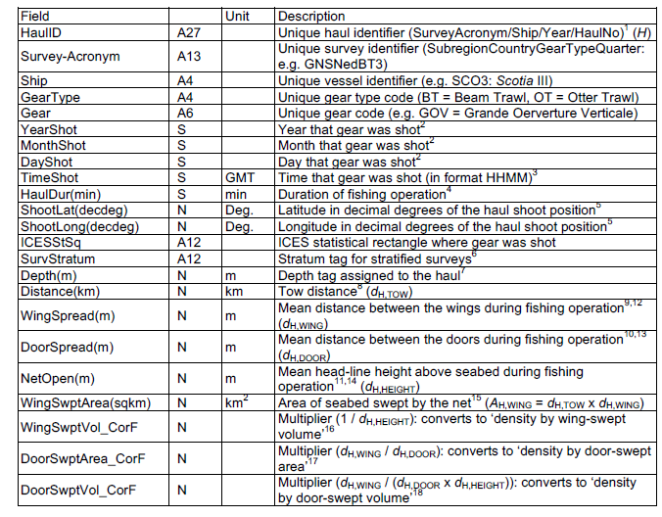

See Appendix X for details of reestimated equations used for missing values in groundspreed, doorspread, wingspread and net opening.

**References**

Moriarty, M., Greenstreet, S.P.R & Ramussen (2017) Derivation of Groundfish Survey Monitoring and Assessment Data Products for the Northeast Atlantic Area. *Scottish Marine and Freshwater Science Report* Vol 8 No 16